Optics

Grand Slam® 5-20x50mm Scopes
Last year, Weaver’s new and improved Grand Slam® Series took the shooting world by storm with a complete transformation inside and out. From advancements to the legendary Micro-Trac® erector system to a new cutting-edge exterior design—the revitalized Grand Slam series is revolutionizing the optics market. For 2014, Weaver is adding two 5-20x50mm Grand Slam scopes crafted especially for shooters looking for powerful magnification and all the light-gathering power of a 50mm objective. Choose from the enduring, versatile Dual-X reticle or the advanced, ballistically-calibrated Varmint EB-X reticle to take your long-range shooting to a new level of precision and style.

Features & Benefits
- Precision ground, fully multi-coated lenses provide clear edge-to-edge viewing
- Argon-purged tubes eliminate internal fogging
- 4X magnification range provides versatile optic performance
- Rugged one-piece, 1-inch tube construction
- Side-focus parallax adjustment for long range precision
- Cross-balanced spring system for repeatable high-precision adjustment of windage/elevation
- Erector contact points aligned around erector tube bulge to eliminate risk of slippage
- Improved material allows more force on the springs to handle heavy recoil and rough use
- Improved erector spring design maximizes force and uniformity throughout travel

Part No. Description UPC MSRP
800670 Grand Slam 5-20x50mm, Dual-X 0 76683 80670 3 $859.95
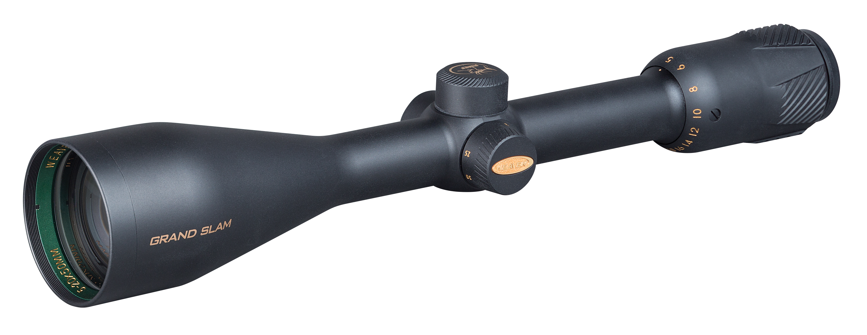
800676 Grand Slam 5-20x50mm, Varmint EB-X 0 76683 80676 5 $879.95

