Optics

6-30x56mm Tactical Scope with SmartZero™
Manufactured to the strictest tolerances, Weaver® tactical scopes are built to perform in the harshest environments. The new 6-30x56mm Tactical Scope is constructed with a one-piece, 34mm body that is rugged enough to withstand all the rigors of real-world operations. It also features Weaver's all-new SmartZero™ turret for quick and accurate return-to-zero functionality, allowing you to make multiple elevation adjustments while still providing quick access to your rifle's absolute zero quickly and positively—with no need for visual reference or counting clicks. The illuminated IMDR first-focal plane, glass-etched reticle boasts an open-center subtention for easy target acquisition and an enhanced mil-dot design to estimate fractions of mils.

Features & Benefits
- Powerful 5-time magnification
- Fully multi-coated lenses with extra-hard coating on exterior lenses
- First focal plane, illuminated IMDR reticle
- Waterproof/shockproof/fogproof
- Side-focus parallax adjustment
- SmartZero reset-to-zero turret
- Argon-purged tubes to eliminate internal fogging
- Rugged 34mm tube with one-piece construction

Part No. Description UPC MSRP
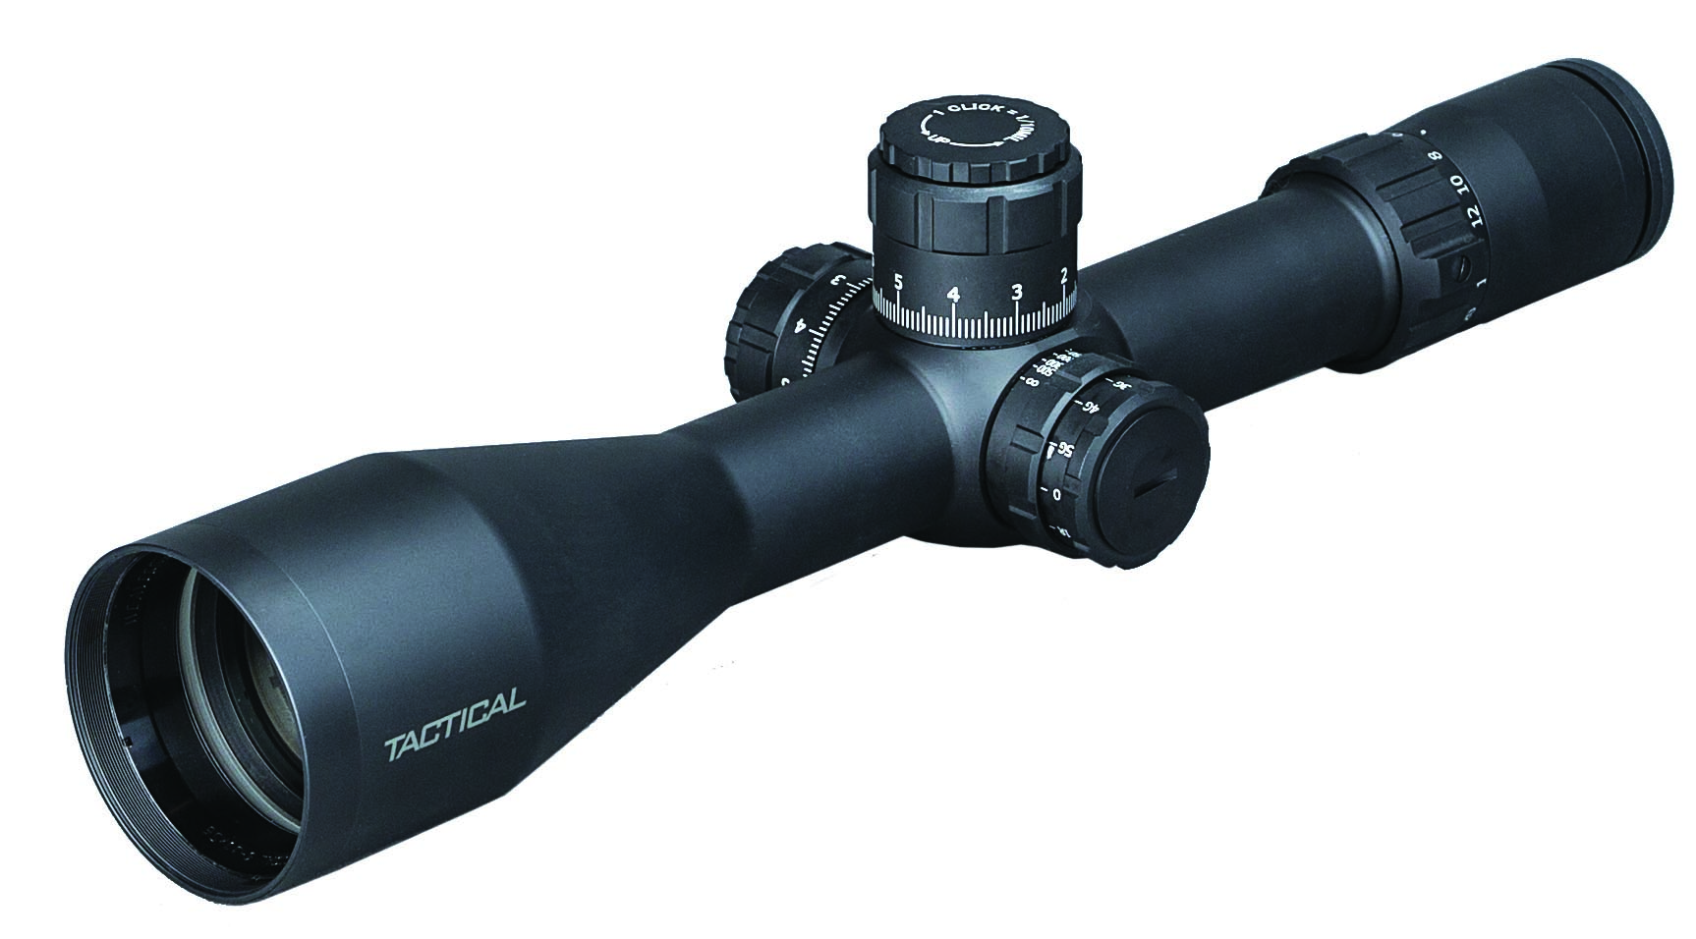
800390 6-30x56mm Tactical 34mm w/SmartZero 0-76683-80390-0 $2,099.99

