ULTIMATE DEFENSE RIFLE
When the stakes are the highest, call on the ultimate in defensive rounds from Remington. When using a modern sporting rifle for your defensive tool of choice, Ultimate Defense Rifle Bonded maximizes your MSR’s power to protect. World-class accuracy meets controlled expansion reliability engineered to offer absolute peace of mind everywhere it matters most.
FEATURES
- The Remington Ultimate Defense line of ammunition has an offering to protect you
- Ultimate Defense Rifle Bonded – Featuring Core-Lokt Ultra Bonded® projectiles, flash-suppressed propellants and Kleanbore® primers for trusted stopping power, low-light performance, and ultimate reliability
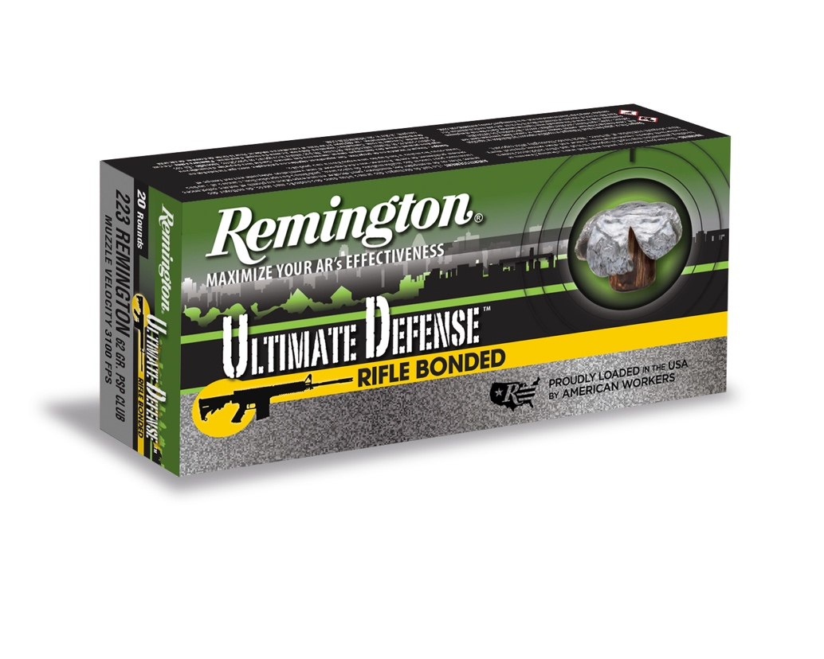

ORDER # | DESCRIPTION | UPC | MSRP
22107 | 223 REM 62GR CORE-LOKT® ULTRA BONDED PSP | 0-47700-47900-2 | $39.99

