PREMIER STS
Shoot to win with a world-class combination of shot-to-shot consistency and reloadability. The choice of champions at major skeet, trap, and sporting clays shoots across the country, Premier STS Target Loads are the benchmark for target-crushing performance and a favorite at the reloading bench. But don’t take our word for it, ask the long list of Remington champions winning with Premier STS. Get ready to crush clays and the competition.
FEATURES
- STS shotgun shells are loaded with Premier shot, primers, powders, and wads
- Available in target, light target, light handicap, and low recoil loads
- High-grade plastic hulls and brass bases allow you to reload these shells many times over.
- STS is now available in select low recoil loads. Go harder on clays and easier on your shoulder

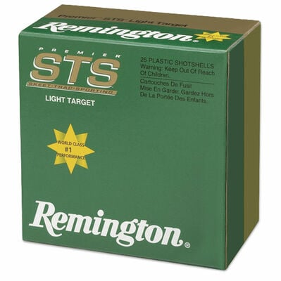
ORDER # | DESCRIPTION | UPC | MSRP
20155 | 12GA 2-3/4IN 2-3/4DRAM 1OZ 8 | 0-47700-30520-2 | $15.99
20110 | 12GA 2-3/4IN 2-3/4DRAM 1-1/8OZ 7.5 | 0-47700-30570-7 | $15.99
20112 | 12GA 2-3/4IN 2-3/4DRAM 1-1/8OZ 8 | 0-47700-30580-6 | $15.99
20114 | 12GA 2-3/4IN 2-3/4DRAM 1-1/8OZ 8.5 | 0-47700-30590-5 | $15.99
20116 | 12GA 2-3/4IN 2-3/4DRAM 1-1/8OZ 9 | 0-47700-30600-1 | $15.99
20250 | 12GA 2-3/4IN 3DRAM 1-1/8OZ 7.5 | 0-47700-30610-0 | $15.99
20252 | 12GA 2-3/4IN 3DRAM 1-1/8OZ 8 | 0-47700-30620-9 | $15.99
20240 | 12GA 2-3/4IN 2-1/2DRAM 1-1/8OZ 8 | 0-47700-3055-9 | $15.99
20242 | NEW 20GA 2-3/4IN 2-1/2DRAM 1-1/8OZ 8 | 0-47700-30560-8 | $15.99
28059 | 20GA 2-3/4IN 2-1/2DRAM 7/8OZ 8 | 0-47700-30060-3 | $15.99
20217 | 20GA 2-3/4IN 2-1/2DRAM 7/8OZ 9 | 0-47700-30050-4 | $15.99
28057 | 28GA 2-3/4IN 2DRAM 3/4OZ 8 | 0-47700-30080-1 | $20.99
28053 | 28GA 2-3/4IN 2DRAM 3/4OZ 9 | 0-47700-30090-0 | $20.99
20750 | 410GA 2-1/2IN MAX 1/2OZ 9 | 0-47700-30110-5 | $20.99

