PREMIER ACCUTIP SABOT SLUG
The deadliest slug round around, Premier® Accutip Sabot Slugs flattens whitetails with devastating ferocity. Guided by the Power Port TipTM, these slugs deliver a degree of accuracy and terminal performance unmatched by any other tested. Consistently printing tiny groups up to 200 yards, Premier Accutip Sabot Slugs transfer tremendous knockdown force at the furthest reaches of shotgun range in 12 or 20-guages. The largest tipped slug you’ll find, bigger does mean better. Only from the ammunition experts at Big Green.
FEATURES
- Molecularly bonded jacket and core. Slug’s jacket made from premier-strength cartridge brass
- High weight retention at all distances – 98% @ 100 yards for both 12 and 20-gauges
- Power Port Tip controls aerodynamics to balance the slug for superior accuracy and range
- All-range expansion – The slug’s spiral nose cuts control expansion for performance at 5-200 yards.
- Size matters – Huge .58 caliber (12-gauge) and .45 caliber (20-gauge) slugs pack a hefty knockdown punch
- Loaded with Premier-quality components
- Designed for use in fully rifled barrels only
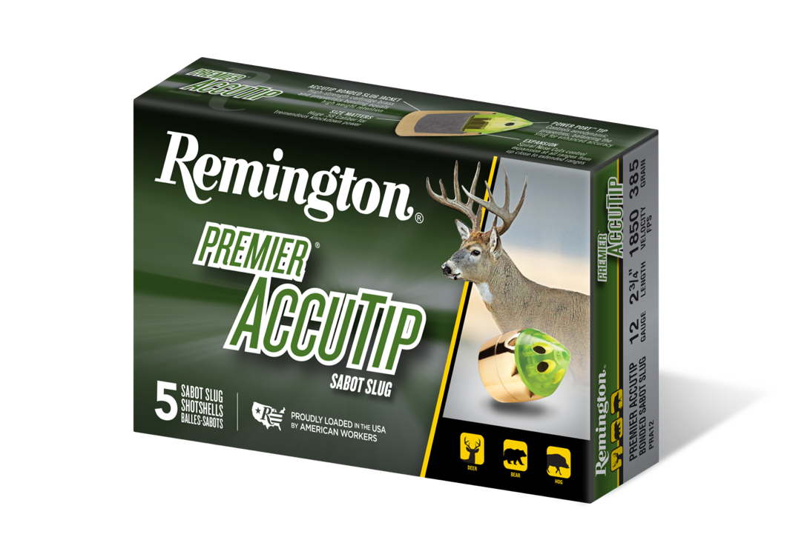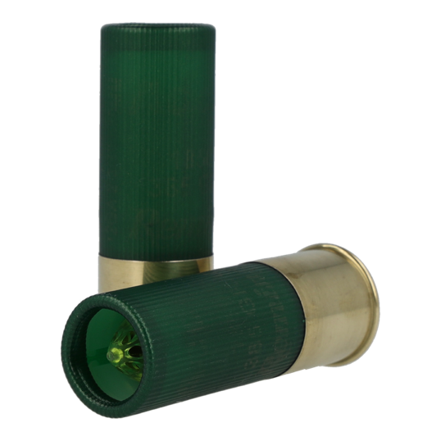
ORDER # | DESCRIPTION | UPC | MSRP
20727 | 12GA 2-3/4IN 385 PPT | 0-47700-33350-2 | $24.99
20731 | 12GA 3IN 385 PPT | 0-47700-35020-2 | $27.99
20496 | 20GA 2-3/4IN 260 PPT | 0-47700-50690-6 | $24.99
20498 | 20GA 3IN 260 PPT | 0-47700-50700-2 | $27.99

