PREMIER® ACCUTIP-V
PRECISELY THE VARMINT HUNTING BULLET OF YOUR DREAMS. ONE SERIOUSLY LETHAL HUNTING TIP.
Optimized to deliver superior match-grade accuracy and maximum downrange energy whenever, and wherever you need it, every time. Specially engineered for varmint hunting, AccuTip-V bullets are optimized for match-grade accuracy and explosive on-game results. At impact, its gold polymer tip is driven rearward causing the thin jacket and soft lead core to fragment violently.
FEATURES
- POLYMER TIP - Eliminates nose deformation
- SLEEK PROFILE - Optimizes ballistic coefficient for flat trajectory
- JACKET THICKNESS - Tuned for violent terminal performance
- MATCH-GRADE ACCURACY
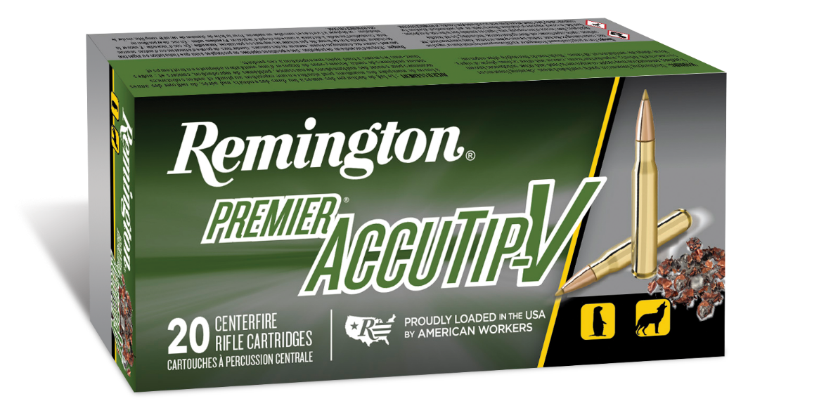
ORDER # | DESCRIPTION | UPC | MSRP
29162 | 17 REM 20GR ACCUTIP-V | 0-47700-36380-6 | $66.99
R29165 | 17 REM FIREBALL 20GR ACCUTIP-V | 0-47700-39610-1 | $51.99
29218 | 204 RUGER 32GR ACCUTIP-V | 0-47700-38310-1 | $34.99
29220 | 204 RUGER 40GR ACCUTIP-V, BOAT TAIL | 0-47700-38320-0 | $34.99
29154 | 22 HORNET 35GR ACCUTIP-V | 0-47700-38440-5 | $83.99
29172 | 221 FIREBALL 50GR ACCUTIP-V, BOAT TAIL | 0-47700-36620-3 | $49.99
29174 | 222 REM 50GR ACCUTIP-V, BOAT TAIL | 0-47700-36630-2 | $34.99
29184 | 223 REM 50GR ACCUTIP-V, BOAT TAIL | 0-47700-36640-1 | $29.99
29192 | 223 REM 55GR ACCUTIP | 0-47700-38170-1 | $35.99
29186 | 22-250 REM 50GR ACCUTIP-V, BOAT TAIL | 0-47700-36650-0 | $40.99
29194 | 243 WIN 75GR ACCUTIP-V, BOAT TAIL | 0-47700-36660-9 | $49.99

