PHEASANT LOAD

We offer the broadest selection of game-specific upland lead shotshells, to bring down the toughest birds' with Remington Pheasant Loads. With their high velocity and long-range performance, they're the perfect choice for any pheasant-hunting situation.
FEATURES

- Standard high-base payloads include 12, 16, and 20 gauge
- Suitable for any pheasant hunt
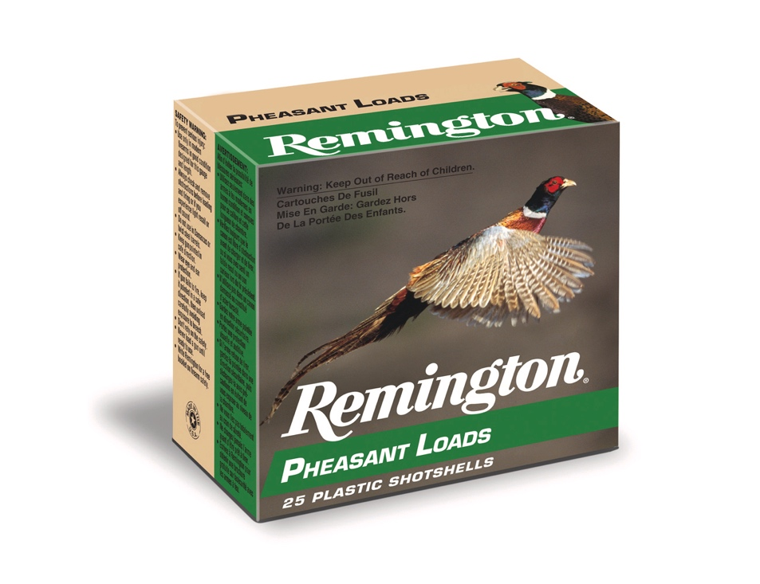

ORDER # | DESCRIPTION | UPC | MSRP
20024 | 12GA 2-3/4IN 1-1/4OZ 5 | 0-47700-32330-5 | $20.99
R20018 | 20GA 2-3/4OZ 1OZ 5 | 0-47700-33220-8 | $20.99
20048 | 12GA 2-3/4IN 1-1/4OZ 6 | 0-47700-04060-8 | $20.99
20054 | 16GA 2-3/4IN 1-1/8OZ 6 | 0-47700-04090-5 | $31.99
20060 | 20GA 2-3/4IN 1OZ 6 | 0-47700-04120-9 | $20.99
20058 | 20GA 2-3/4IN 1OZ 4 | 0-47700-04111-7 | $20.99
20050 | 12GA 2-3/4IN 1-1/4OZ 7.5 | 0-47700-04070-7 | $20.99
20046 | 12GA 2-3/4IN 1-1/4OZ 4 | 0-47700-04050-9 | $20.99

