HYPERSONIC STEEL
It’s a simple fact. Most ducks are missed from behind. The good news? The unprecedented velocity of Remington Hypersonic Steel® compensates by getting your shot on target faster – reducing the lead on flying fowl by a full body length at 40 yards. The result: more pellets on game for quicker kills, fewer misses, and a full bag limit – all without changing the way you shoot. Hypersonic Steel takes waterfowl lethality to deadly new heights.
FEATURES
- The world’s fastest, hardest-hitting steel
- 1,700 FPS gives you an 8” lead advantage or 11% shorter lead at 40 yards
- Patented XceleratorTM wad technology – Delivers record velocity while holding patterns downrange
- Featuring Premier-quality components, including zinc-plated steel shot, Remington high-tensile hulls and carefully chosen propellant/primer combinations for optimal velocity and performance
- Fully compatible with ported and wad-stripping chokes
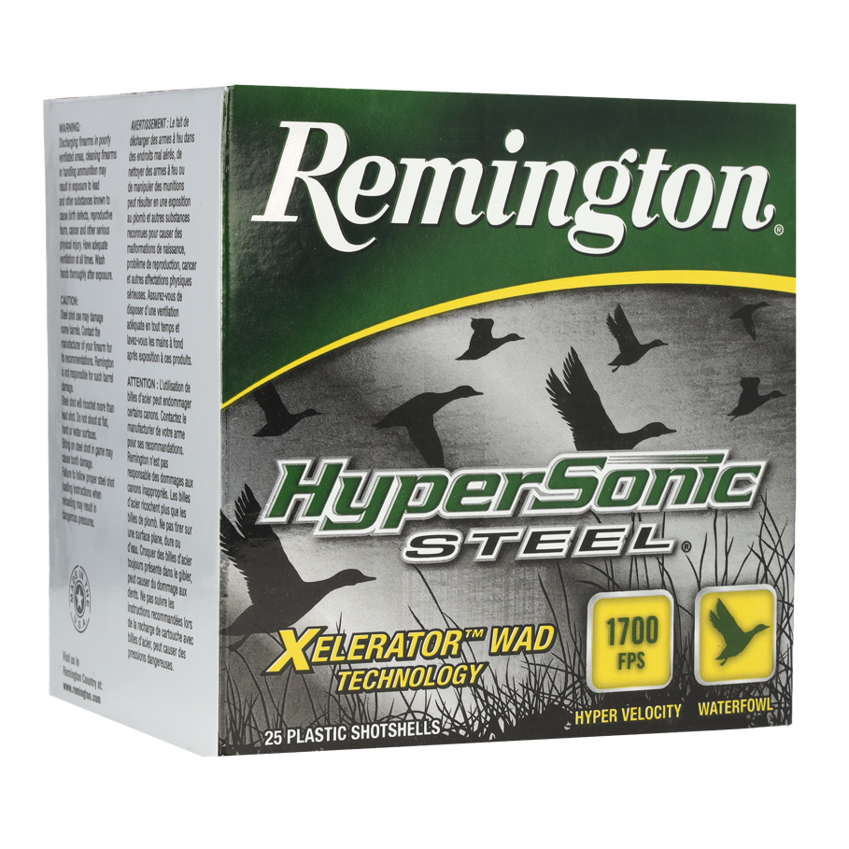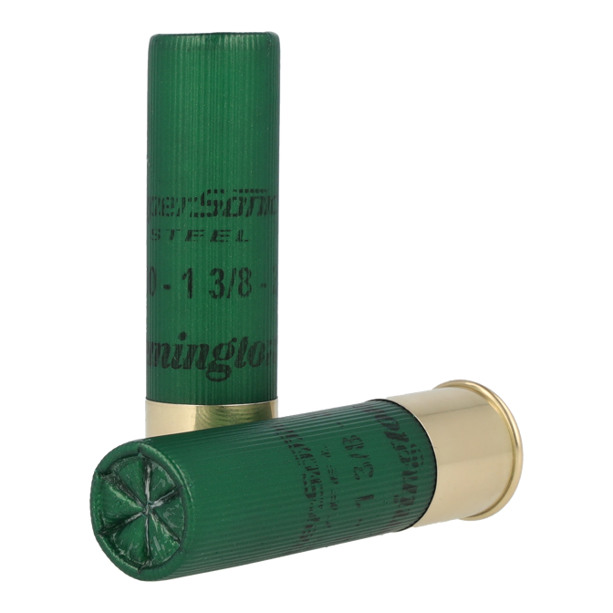
ORDER # | DESCRIPTION | UPC | MSRP
26724 | 10GA 3-1/2IN 1-1/2OZ BBB | 0-47700-51080-4 | $65.99
26726 | 10GA 3-1/2IN 1-1/2OZ BB | 0-47700-51090-3 | $65.99
26728 | 10GA 3-1/2IN 1-1/2OZ 2 | 0-47700-51100-9 | $65.99
26741 | 12GA 3IN 1-1/8OZ BB | 0-47700-50970-9 | $40.99
26743 | 12GA 3IN 1-1/8OZ 2 | 0-47700-50980-8 | $40.99
26745 | 12GA 3IN 1-1/8OZ 4 | 0-47700-50990-7 | $40.99
26769 | 12GA 3IN 1-1/4OZ BB | 0-47700-51000-2 | $41.99
26771 | 12GA 3IN 1-1/4OZ 1 | 0-47700-51010-1 | $41.99
26775 | 12GA 3IN 1-1/4OZ 2 | 0-47700-51020-0 | $41.99
26776 | 12GA 3IN 1-1/4OZ 3 | 0-47700-51200-6 | $41.99
26777 | 12GA 3IN 1-1/4OZ 4 | 0-47700-51030-9 | $41.99
26793 | 12GA 3-1/2IN 1-3/8OZ BB | 0-47700-51040-8 | $54.99
26795 | 12GA 3-1/2IN 1-3/8OZ 2 | 0-47700-51050-7 | $54.99
26799 | 12GA 3-1/2IN 1-3/8OZ 4 | 0-47700-51060-6 | $54.99
26823 | 20GA 3IN 7/8OZ 2 | 0-47700-51110-8 | $39.99
26825 | 20GA 3IN 7/8OZ 4 | 0-47700-51130-6 | $39.99

