HTP HANDGUN
High Terminal Performance or HTP Handgun is equally as good for personal defense and bringing down big game. Now available for the first time in powerful 10mm Auto, Remington is also expanding the HTP handgun lineup with a new 30 Super Carry load as well. Also new for 2022 is 20-round pack options for 41 Rem Mag, 44 Rem Mag, and 45 Colt, giving handgun and revolver shooters and hunters more choice afield and at the range.
FEATURES
- Optimized for personal defense. Equally as potent for handgun hunting
- Performs reliably through any length barrel
- Premier primers, brass cases and propellants
- HTP Handgun also available in all major defensive calibers, in standard and many +P loads

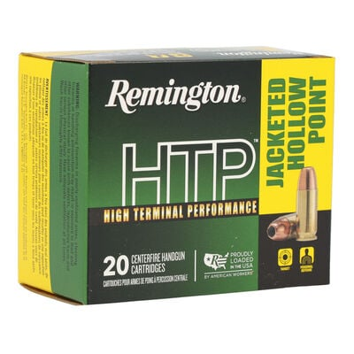

ORDER # | DESCRIPTION | UPC | MSRP
28288 | 9MM 115GR JHP | 0-47700-49630-6 | $23.99
28293 | 9MM LUGER +P 115GR JHP | 0-47700-49640-5 | $23.99
28295 | 9MM LUGER 147GR JHP | 0-47700-49650-4 | $23.99
22227 | 357 MAG 110GR SHJP | 0-47700-49720-4 | $36.99
22231 | 357 MAG 158GR SJHP | 0-47700-49710-8 | $36.99
22233 | 357 MAG 1158GR SP | 0-47700-49620-7 | $36.99
22295 | 38 SPL +P 110GR SJHP | 0-47700-49750-1 | $21.99
22303 | 38 SPL +P 125GR SJHP | 0-47700-49670-2 | $21.99
22297 | 38 SPL +P 158GR LHP | 0-47700-49760-0 | $21.99
22248 | 380 AUTO 88GR JHP | 0-47700-49660-3 | $23.99
22306 | 40 S&W 155GR JHP | 0-47700-49680-1 | $28.98
22308 | 40 S&W 155GR JHP | 0-47700-49680-1 | $28.99
R21453 | 45 AUTO 185GR JHP | 0-47700-49700-6 | $31.99
21455 | 45 AUTO 230GR JHP | 0-47700-49710-5 | $31.99
R22019 | NEW 30 Super Carry 100GR JHP | 0-47700-48710-6 | $28.99
23000 | NEW 41 REM MAGNUM 210GR JSP HTP | 0-47700-48670-3 | $48.99
23002 | NEW 44 REM MAGNUM 240GR JSP HTP | 0-47700-48680-2 | $36.99
23010 | NEW 44 REM MAGNUM 240GR SJHP HTP | 0-47700-48690-1 | $37.99
23012 | NEW 45 COLT 230GR JHP HTP | 0-47700-48700-7 | $35.99

