HIGH PERFORMANCE RIFLE

Proof of our dedication to providing you with the widest selection of centerfire ammunition in the industry, our High Performance Rifle series consists of a multitude of calibers and popular bullet styles. All assembled with premium components and the ultra-tight tolerances that put more home reloading presses on the back shelf than any other brand.
FEATURES

- Offered in a wide range of calibers and bullet styles
- Catered to your specialized hunting and shooting pursuits
- Made with premium components

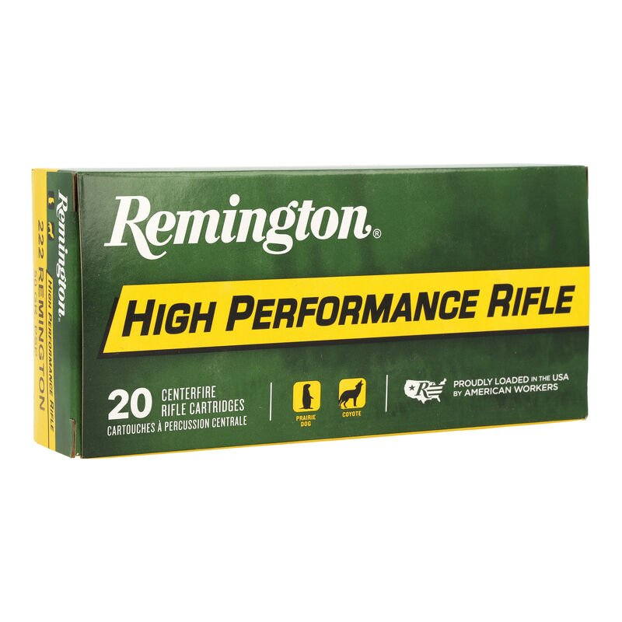

ORDER # | DESCRIPTION | UPC | MSRP
27800 | 243 WIN PSP 80GR | 0-47700-05170-3 | $35.99
21303 | 222 REMINGTON PSP 50GR | 0-47700-05040-9 | $36.99
28399 | 223 REMINGTON PSP 55GR | 0-47700-05090-4 | $40.99
21297 | 220 SWIFT PSP 50GR | 0-47700-07830-4 | $72.99
28410 | 32-20 WIN LRN 100GR | 0-47700-05670-8 | $105.99
28460 | 17 REMINGTON HP 25GR | 0-47700-31420-4 | $71.99
21311 | 22-250 REMINGTON PSP 55GR | 0-47700-05120-8 | $40.99
21499 | 35 WHELEN PSP 250GR | 0-47700-07070-4 | $90.99
29340 | 375 REM ULTRA MAGNUM SP 270GR | 0-47700-35320-3 | $99.99
28376 | 22 HORNET PSP 45GR | 0-47700-05020-1 | $91.99
29097 | 375 H&H MAGNUM SP 270GR | 0-47700-05730-9 | $109.99
21463 | 45-70 GOVERNMENT SJHP 300GR | 0-47700-47530-1 | $66.99

