**EXPRESS EXTRA LONG RANGE**

Simply, the best-balanced, tightest-patterning upland field loads available. Now in a bold new look, and the same premium performance decades of shooters have come to know and trust. The time-proven excellence of Express® XLR Extra Long Range line now with five brand new loadings - 12 gauge to 410 bore - and shot sizes ranging from #2 all the way down to #7 1/2 for everything from pheasant and quail to rabbits and squirrels.

**FEATURES**

* Tightest-patterning upland field loads available
* Remington Power Piston one-piece wad cushions and protects shot and prevents barrel leading
* Wad’s base seals gas behind shot column to deliver maximum energy and tight, even patterns
* 2 shot down to 7 ½

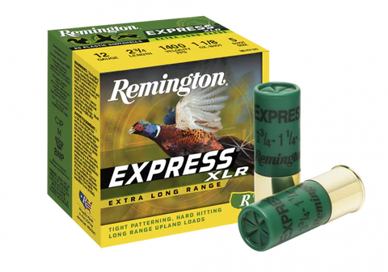

|  |  |  |  |
| --- | --- | --- | --- |
| **ORDER #** | **DESCRIPTION** | **UPC** | **MSRP** |
| 20143 | 12GA 2-3/4IN 1-1/4OZ 2 | 0-47700-01520-0 | $25.99 |
| 20145 | 12GA 2-3/4IN 1-1/4OZ 4 | 0-47700-01530-0 | $25.99 |
| 20147 | 12GA 2-3/4IN 1-1/4OZ 5 | 0-47700-01540-8 | $25.99 |
| 20149 | 12GA 2-3/4IN 1-1/4OZ 6 | 0-47700-01550-7 | $25.99 |
| 20151 | 12GA 2-3/4IN 1-1/4OZ 7.5 | 0-47700-01560-6 | $25.99 |
| 20167 | 12GA 2-3/4IN 1-1/8OZ 5 | 0-47700-51920-3 | $20.99 |
| 20168 | 12GA 2-3/4IN 1-1/8OZ 6 | 0-47700-51910-4 | $20.99 |
| 20169 | 12GA 2-3/4IN 1-1/8OZ 7.5 | 0-47700-51900-5 | $20.99 |
| 28003 | 16GA 2-3/4IN 1-1/8OZ 4 | 0-47700-01580-4 | $31.99 |
| R28007 | 16GA 2-3/4IN 1-1/8OZ 6 | 0-47700-01600-9 | $31.99 |
| 28009 | 16GA 2-3/4IN 1-1/8OZ 7.5 | 0-47700-01610-8 | $31.99 |
| R20333 | 20GA 2-3/4IN 1OZ 4 | 0-47700-01630-6 | $25.99 |
| 20335 | 20GA 2-3/4IN 1OZ 5 | 0-47700-01640-5 | $25.99 |
| 20337 | 20GA 2-3/4IN 1OZ 6 | 0-47700-01650-4 | $25.99 |
| 20339 | 20GA 2-3/4IN 1OZ 7.5 | 0-47700-01660-3 | $25.99 |
| 20181 | 20GA 2-3/4IN 7/8OZ 6 | 0-47700-51940-1 | $20.99 |
| 20183 | 20GA 2-3/4IN 7/8OZ 7.5 | 0-47700-51930-2 | $20.99 |
| 28047 | 28GA 2-3/4IN 3/4OZ 6 | 0-47700-01680-1 | $33.99 |
| 28049 | 28GA 2-3/4IN 3/4OZ 7.5 | 0-47700-01690-0 | $33.99 |
| 20743 | 410GA 2-1/2IN 1/2OZ 4 | 0-47700-01700-6 | $24.99 |
| 20745 | 410GA 2-1/2IN 1/2OZ 6 | 0-47700-01710-5 | $24.99 |
| 20747 | 410GA 2-1/2IN 1/2OZ 7.5 | 0-47700-01720-4 | $24.99 |
| 20771 | 410GA 3IN 11/16OZ 4 | 0-47700-01730-3 | $28.99 |
| 20775 | 410GA 3IN 11/16OZ 6 | 0-47700-01750-1 | $28.99 |
| 20777 | 410GA 3IN 11/16OZ 7.5 | 0-47700-01760-0 | $28.99 |