22 CYCLONE

Prairie dogs. Tin cans. Or a bulls-eye. No matter what you put in your sights, Remington® Cyclone is the perfect 22 rimfire ammunition. Remington rimfire ammunition delivers the same quality you expect from our centerfire ammunition, so you'll get the maximum performance from every shot.
FEATURES

- Ideal ammo for any occasion
- Designed for maximum performance shot after shot

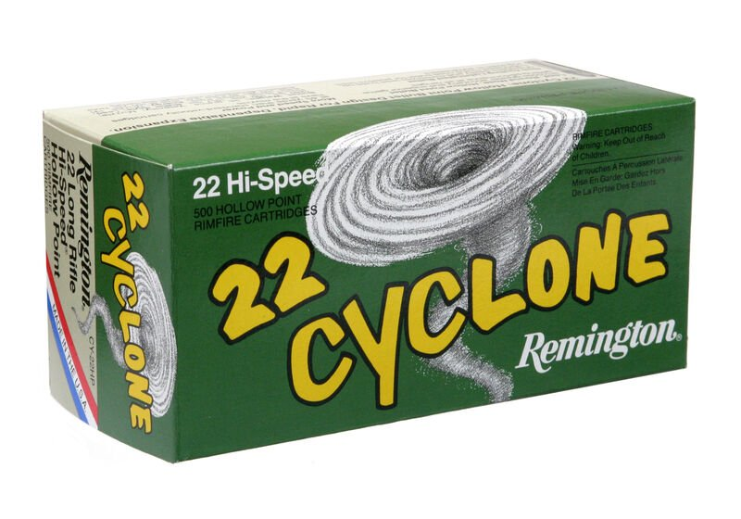

ORDER # | DESCRIPTION | UPC | MSRP
21222 | 22 LR 36GR | 0-47700-00350-4 | $5.99

