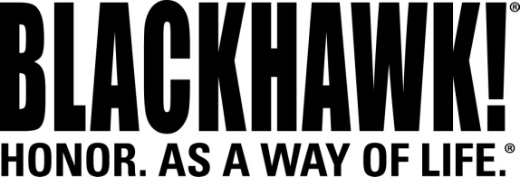

2015 NEW Products
Bags & Packs

Go Box Admin Pouch
The new Go Box Admin Pouch features multiple pockets and elastic loops for organizing pens, chem-lights and other critical items. It is part of the new series of Go Box Hook-Back Accessories that are designed to attach to the built-in loop panels on popular BLACKHAWK!® bags and packs. These accessories are engineered with high-quality hook-back panels to mount to the interior loop-lined surfaces of the bags. They feature the same quality components found throughout the Go Box line, including YKK zippers and 500 denier nylon. The Go Box Admin Pouch mounts to any loop/Velcro® surface and can be easily removed or repositioned at will.

Features & Benefits
- Multiple pockets and elastic loops for organizing pens, chem-lights, and other critical small items
- Flashlight pocket with adjustable lid fits handheld lights
- Hook-back panel mounts to any loop surface
- Dimensions: 5.5”H x 7.0”W

Part No. Description UPC MSRP
22GA07BK Go Box Admin Pouch - Black 6 48018 21651 $24.99
